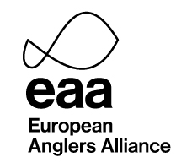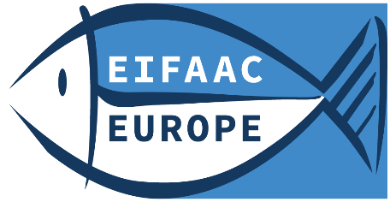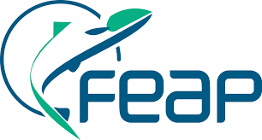

Subject: European inventory of fish damages caused by cormorant predation
Dear angling organisation,
The European Inland Fisheries and Aquaculture Advisory Commission (EIFAAC), the Federation of European Aquaculture Producers (FEAP) and the European Anglers Alliance (EAA) seek your assistance.
The objective of this survey is to produce a European inventory of damage and losses caused by cormorants and other predators to inland fish, recreational fisheries and aquaculture, to:
- inform EU and national policy makers of the economic impact cormorant predation has on our sectors;
- inform you of the various damage compensation systems used throughout Europe;
- contribute to the development of a European Cormorant Management Plan; and
- increase public awareness of the consequences of large-scale predation of fish concerning food security, aquatic biodiversity, fishing and aquaculture dependent businesses and rural incomes.
The initial outcomes of this inventory will be presented to the Conference on management advice to reduce cormorant predation impacts, which will be hosted by the Polish Presidency to the European Council on 3 June 2025 in Brussels. This conference provides an excellent opportunity to bring our concerns to the attention of the recently elected European parliamentarians and other key stakeholders.
The inventory results will be made available online and a report will be published in 2025 as a joint EIFAAC, FEAP, EAA publication.
We would be grateful for your collaboration in the survey and contribution to our inventory.
We ask you to please assist us by filling in the questionnaire below on the numbers of cormorants and other fish predators in your country and your locality if possible. Also, which fish species are threatened by cormorant predation in your area (evidenced and/or ‘expert’ backed data preferred). What is the cost of restocking, scaring of birds, loss of angling members and fees etc., which can be referred to unsustainable levels of predation by cormorants and other fish predators.
We would like to collect damage information from 2024 and 2023. Information from earlier years would also be appreciated.
Please submit the questionnaire on this letters page 3 to the EIFAAC secretariat:
EIFAAC-Secretariat@fao.org before 31 March 2025
This will allow us to compile and analyze the data received on time for the conference and finalize an overview publication this year.
This letter is sent to national angling organizations only. If your regional or local angling clubs should be involved you can, of course, send them a copy of this letter. We leave it to you to decide on that, and if such additional responses should be submitted to you or directly to us.
If you have any questions, please contact:
EAA info@eaa-europe.eu or
the EIFAAC secretariat EIFAAC-Secretariat@fao.org
We thank you in advance for your participation in this joint survey.
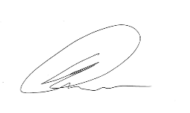
With best regards,

Mark Owen, EAA President
Contact:
Jan Kappel, Secretary General
European Anglers Alliance, EAA
Rue de la Loi 81a, B-1000 Brussels, Belgium
www.eaa-europe.eu | jan.kappel@eaa-europe.eu
Transparency Register No: 60105502183-69
Mobile: +32 (0)471 68 38 84 | Office phone: +32 (0)2 725 11 15
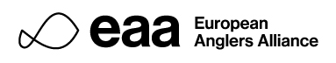

Questionnaire to angling organisations – damage by cormorants 2023, 2024
Please fill in this questionnaire. For fields you have no data just write na.

Your country or location: xxx
Predator impact  (cormorants + other predators = 100%) | 2023 | 2024
Number of cormorants
Breeding pairs (if any) :
Nests counted (= breeding pairs):
Estimated cormorant days (per year):
Nesting birds (nests x 2)
+ non-breeders/(1.5 bird per nest)
Visiting birds from other countries:
(eventually give an estimate for the month with the highest number and the month with the lowest number).
Other predators
Names:
Predator impact on fish, in percentages:
Cormorants:
Other predators:
= 100%
Which fish species are threatened by cormorants? Nationally? Locally?
Economic impact
What is the damage cost in euro?
Please include cost for scarring, monitoring, restocking, loss of club members, loss of fees etc. (name other costs if any). Please estimate or reference a national cost figure, eventually accompanied by one or more local figures/cases.
Compensation schemes
What compensation schemes are available for angling organisations in your country?
Did your organization receive any compensation? Do you have link(s) to any such compensation scheme(s)?
References/links to relevant studies:
Other information you find relevant for this survey?

